Kingdom of Saudi Arabia  Ministry of Education  Eastern Province Education Department  Tarbeat Al-Ajial International Schools  in Hafr Al-Batin |  |  |  |  |  |  | Date: ……/………/..………  Subject: Computer  Grade: G6
……………… |  | Seat Number |  | ……………………………………….. |  |  |  | Student’s Name
1st Semester Exam (1St Session) 20…./20….
Sign. | Consultative Name |  | Sign. |  | Corrector’s Name | Marks in letters |  |  | Marks  in numbers
 |  |  |  |  |  |  |  |  | 40
Q1: Match the following:
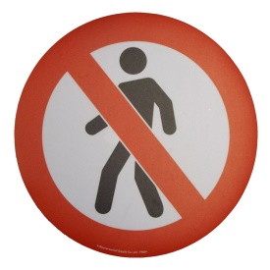 | Smart TV
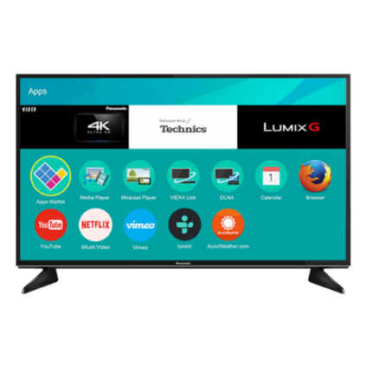 | Stop Sign
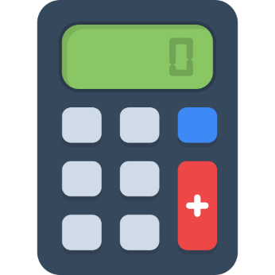 | Calculator
 | Wash Hands
 | No Call

Q2: Choose the correct answer from the following:
- The dimensions of an A4 size paper are
21.0 cm | 29.7 cm



Q3: Put (✔) or (✘):
 | CLI | (………………………)
 | Shopping Cart | (………………………)
 | Gift | (………………………)
Good Luck

